Operational Research: Tutorial 5
  - Mixed Integer Programming
The more complicated questions on the tutorial are marked by:
* Medium
** Hard

Exercises
- Table 1 gives weights and survival values for items that can be chosen to take with you to a desert island. You can carry 15kg.
  - Maximise the survival value of your selection.
$w_{i}$ – weight of item $i$ (kg)
$s_{i}$ – survival value of item $i$ (kg)

Maximise
$$\sum_{i=1}^{6}{s_{i}x_{i}}$$
subject to:
$$\sum_{i}{w_{i}x_{i}}≤15$$
and
$$x_{i}≥0$$
$$x_{i}≤1$$
$$x_{i}∈z$$

  - Assume that you can pick an item more than once. (This would probably be a bad idea in practice!)
Maximise
$$\sum_{i=1}^{6}{s_{i}x_{i}}$$
subject to:
$$\sum_{i}{w_{i}x_{i}}≤15$$
and
$$x_{i}≥0$$
$$x_{i}∈z$$

  - Ignoring b), assume that you must pick at least 5 items.

Item | Weight (kg) | Survival Value
1 | 2 | 10
2 | 3 | 50
3 | 2 | 40
4 | 6 | 100
5 | 6 | 100
6 | 8 | 130
7 | 3 | 70
8 | 5 | 80
Table 1

Maximise
$$\sum_{i=1}^{6}{s_{i}x_{i}}$$
subject to:
$$\sum_{i}{w_{i}x_{i}}≤15$$
$$\sum_{i}{x_{i}}≥5$$

and
$$x_{i}≥0$$
$$x_{i}≤1$$
$$x_{i}∈z$$
The optimal solutions for the three MILP models are given below. Please look at the code to see the implementations.
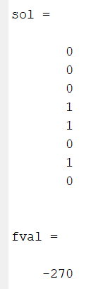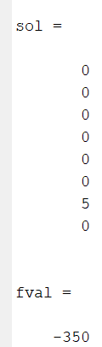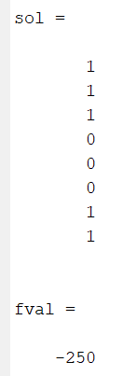

- Table 2 gives the cities that would be safely covered by a fire station located at the given city. Formulate a set covering problem to minimise the number of fire stations that require building so that every city is safely covered. In which cities should the fire stations be built?

City | Covers
1 | 1,2,3
2 | 1,2,4
3 | 1,3
4 | 2,4,5
5 | 4,5,6
6 | 5,6,7
7 | 6,7
Table 2
minimise
$$\sum_{i}{x_{i}}$$
subject to:
$x_{1}+x_{2}+x_{3}≥1$ (City 1 Constraint)
$x_{1}+x_{2}+x_{4}≥1$ (City 2 Constraint)
$x_{1}+x_{3}≥1$ (City 3 Constraint)
$x_{2}+x_{4}+x_{5}≥1$ (City 4 Constraint)
$x_{4}+x_{5}+x_{6}≥1$ (City 5 Constraint)
$x_{5}+x_{6}+x_{7}≥1$ (City 6 Constraint)
$x_{6}+x_{7}≥1$ (City 7 Constraint)
and
$$x_{i}∈\left\{0,1\right\}, ∀i$$

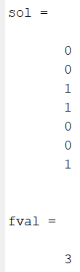
Note you might get a different selection, but the minimum will be 3!
- C&S (Management Consultants) have been employed to help the Icki-Toffee Company to develop a popular, economical but more health-conscious selection of candies to add to their scrumptious range of toffees. There has been much publicity that the Government are so worried about obesity that they plan to introduce a coding system for all food products which will inform the public about products containing foods which may be adding to the problem. There are rumours that the Government aim to strongly promote the concept of fruit as a healthy alternative to sweets, so Icki-Toffee are very keen to introduce fruit, in the form of fillings, soft centres etc into their range. They are determined to ensure that at least one of their selections of candies does not fall into the worst category.

- The selection chosen must weigh more than 320g
- Total fat content by weight must be less than 45% of the total weight of the selection.
- Calorific value of the selection must be less than 2850 calories.
- Total weight is limited to 1.5 times the minimum weight of 320g
The quantities of fat, calories, weight and cost for each candy are given in Table 3.
Minimise the total cost subject to the following: **
- Ensure that your selection has at least 6 different candies
- Ensure your selection includes at least 3 of each of the selected candies.
- Limit selected candies to a maximum of 6 each in your selection
Candy - $x_{i}$ | Fat (g) - $F_{i}$ | Calories – $K_{i}$ | Weight (g) - $W_{i}$ | Cost - $C_{i}$
Buttery butterscotch | 20 | 100 | 24 | 12
Caramel softie | 16 | 100 | 22 | 12
Orange dream | 10 | 80 | 15 | 12
Coconut Ice | 7 | 50 | 12 | 15
Lemon sorbet | 6 | 60 | 10 | 13
Lime sherbet | 5 | 40 | 10 | 13
Strawberry surprise | 13 | 80 | 14 | 16
Raspberry mousse | 15 | 90 | 17 | 16
Ginger toffee | 18 | 80 | 20 | 15
Rose-water posy | - | 145 | 8 | 10
Walnut whirl | 19 | 120 | 20 | 18
Grape bunch | - | 120 | 15 | 20
Table 3: Table to show content information about each candy

$x_{i}$ – number of item $i$ selected
$δ_{i}=\left\{\begin{aligned}1-item i selected \\ 0- item i not selected\end{aligned}\right.$

minimise
$$\sum_{i}{C_{i}x_{i}}$$
subject to:
$$\sum_{i}{W_{i}x_{i}≥320} \\ \sum_{i}{K_{i}x_{i}≤2850} \\ \sum_{i}{F_{i}x_{i}≤0.45\sum{W_{i}x_{i}}} \\ \sum_{i}{δ_{i}≥6} \\ x_{i}≥3δ_{i} \\ x_{i}≤6δ_{i}$$
and
$x_{i}≥0, ∀i$
$$x_{i}∈Z, ∀i$$
$$δ_{i}∈\{0,1\}, ∀i$$

Check out the code for this, the left column below is the $x_{i}$ values and the right column is the $δ_{i}$ values
